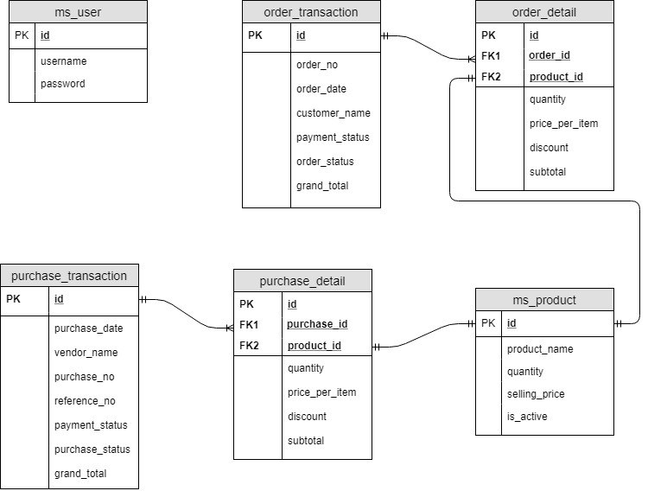

|  |  |
| --- | --- |
| ms_user  this table is used to store the credential to login to the page | |
| id | serial id for the table |
| username | username of the user |
| password | password of the user (md5) |

|  |  |
| --- | --- |
| order_transaction  this table is used to store the order (selling) transaction | |
| id | serial id for the table |
| order_no | order number, generated automatically for every order |
| order_date | order date |
| customer_name | customer name |
| payment_status | status of payment, filled with Pending / Paid |
| order_status | status of order, filled with On Process / Shipped |
| grand_total | amount paid of each order |

|  |  |
| --- | --- |
| order_detail  this table is used to store the detail of each order | |
| id | serial id for the table |
| order_id | order_transaction id |
| product_id | ms_product_id |
| quantity | number of quantity of the product |
| price_per_item | price per item of the product |
| discount | discount for the product |
| subtotal | (quantity * price_per_item) - discount |

|  |  |
| --- | --- |
| ms_product  this table is to store the product detail | |
| id | serial id for the table |
| product_name | product name |
| quantity | current quantity in store |
| selling_price | selling price |
| is_active | true / false, to determine the availability of the product |

|  |  |
| --- | --- |
| purchase_transaction  this table is used to store the purchase (buying) transaction | |
| id | serial id for the table |
| purchase_date | purchase date |
| vendor_name | vendor name |
| purchase_no | internal purchasing number |
| reference_no | vendor’s PO / invoice number |
| payment_status | status of payment, filled with Pending / Paid |
| purchase_status | status of order, filled with Process / Received |
| grand_total | amount paid of each purchase |

|  |  |
| --- | --- |
| purchase_detail  this table is used to store the detail of each purchase | |
| id | serial id for the table |
| purchase_id | purchase_transaction id |
| product_id | ms_product_id |
| quantity | number of quantity of the product |
| price_per_item | price per item of the product |
| discount | discount for the product |
| subtotal | (quantity * price_per_item) - discount |